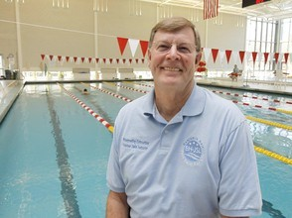
Gordon Hair has made it his mission to “waterproof” Central Virginia by teaching 50,000 children to swim. Through his nonprofit organization, the Ben Hair — Just Swim for Life Foundation, Hair has begun to set up sustainable programs to teach low- income children to swim.“The mission of our program would be to train 50,000 kids how to swim by 2016 and waterproof the Charlottesville area,” Hair said. “When we say waterproof, we’re really talking about a child being able to swim 25 yards on his front
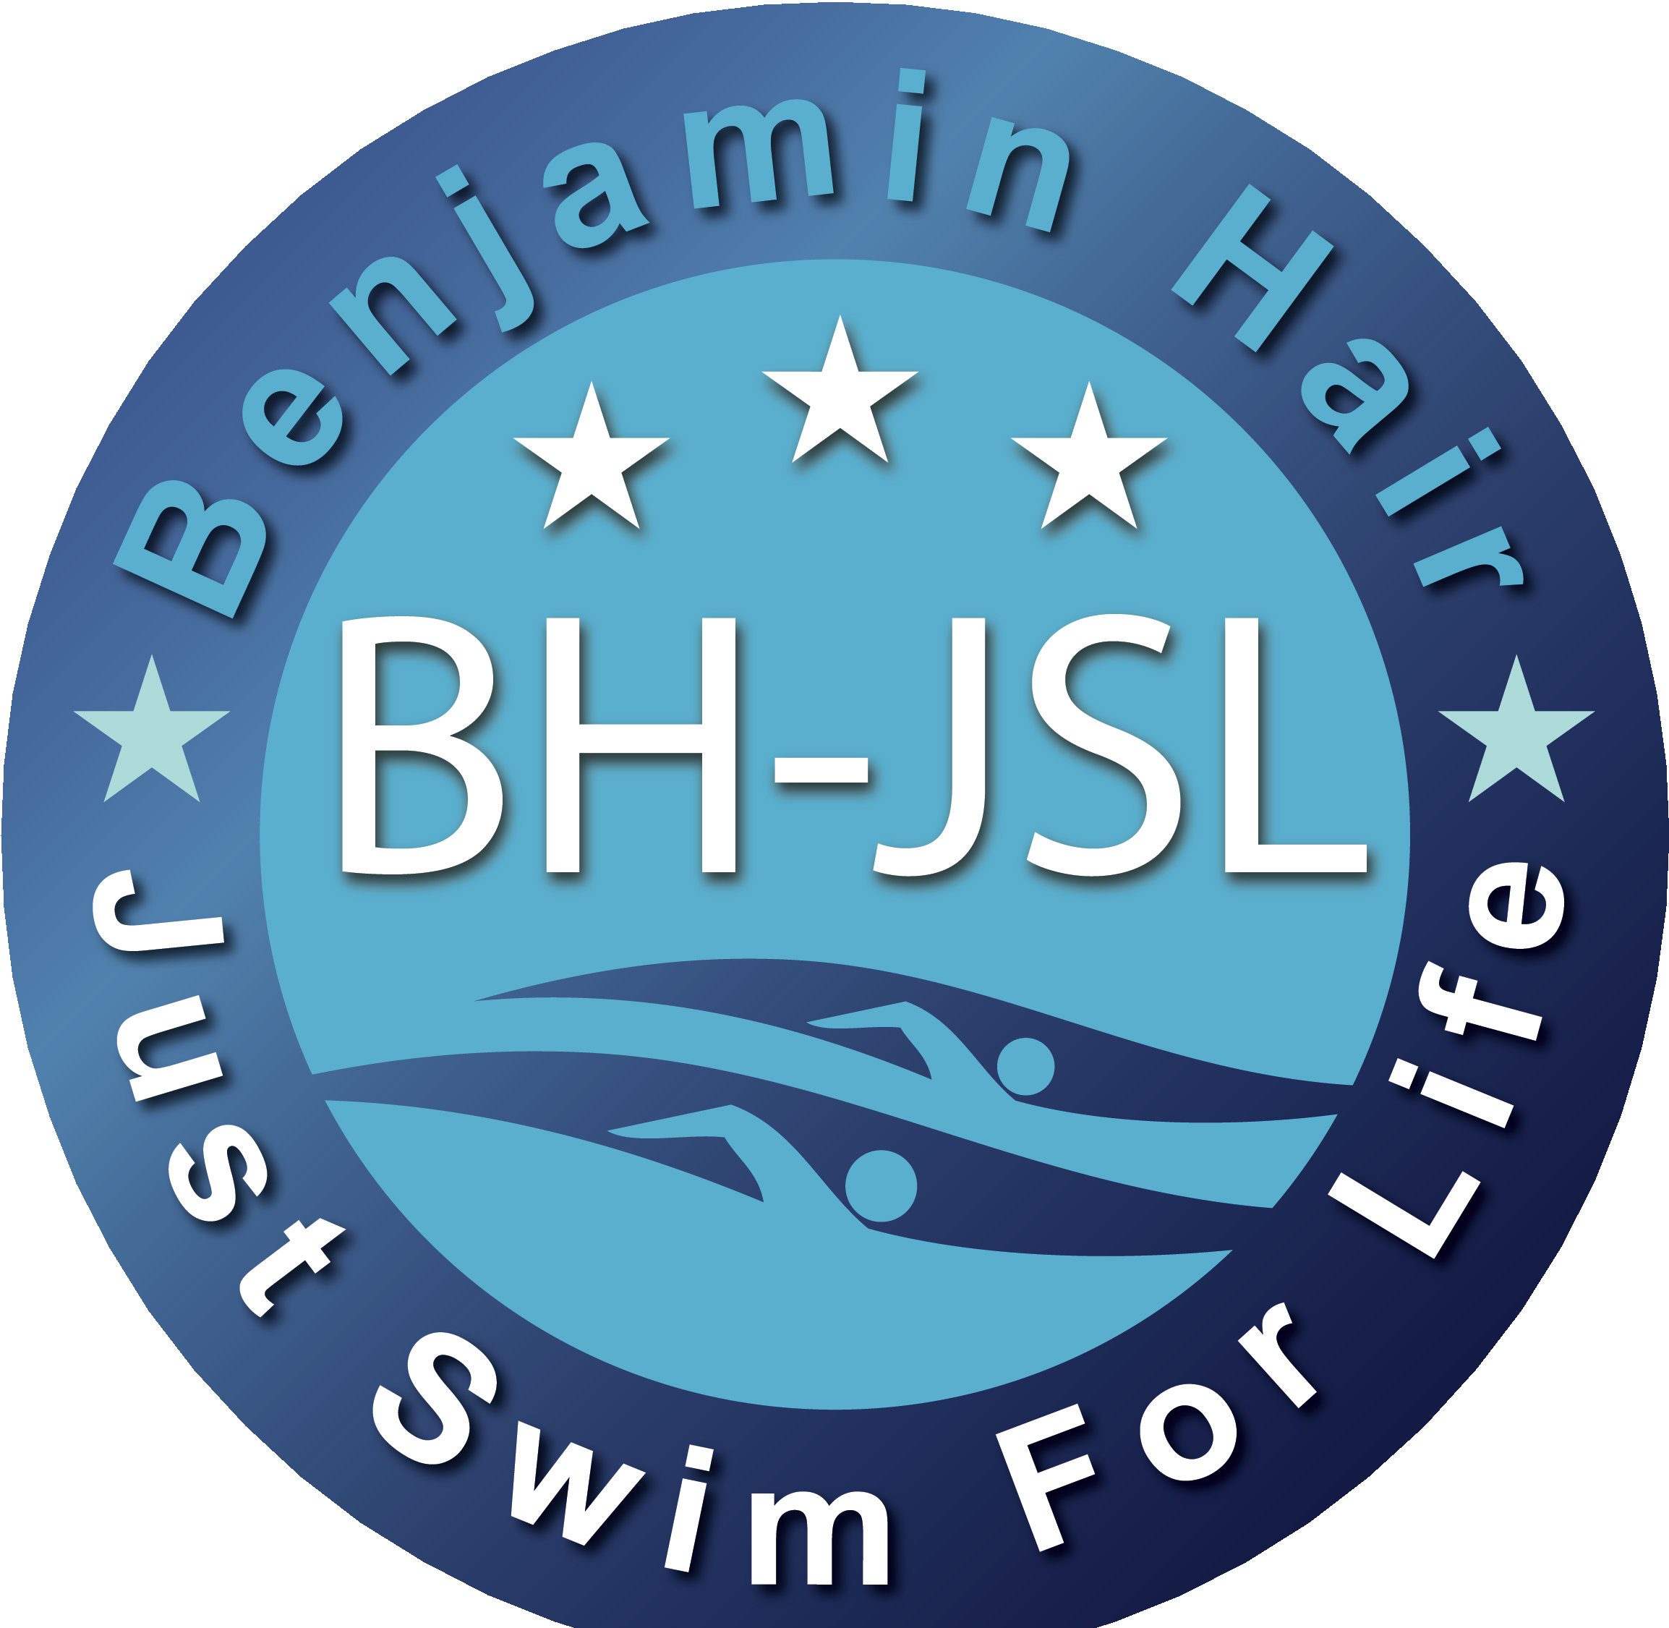
and 25 yards on his back, and that’s really our goal for each swim lesson.”The foundation is named after Hair’s son Ben, who spent his entire life in and around the water, and was a lifeguard in Charlottesville for four years. Ben Hair died in December 2009 in a car wreck. The loss, Gordon Hair said, inspired him to set up the swimming foundation in his son’s honor. With the help of some dedicated community members, the Ben Hair – Just Swim for Life Foundation began to come together shortly after Ben’s death. “We started in early 2010, and put together a think tank which involved about 60 people out of the community to come together and … validate the goals we had decided for ourselves,” said Hair, who retired two years ago after 43 years working for CVS Pharmacy. The coming together, Hair said, was initiated by family and friends of the Hairs. Ben swam competitively for most of his life, including in the Jefferson Swim League, a competitive recreational swim league founded in 1966, during the summers. Connections Ben had made through swimming began urging Hair and his wife, Brenda, to honor Ben’s memory with a foundation. One of those friends was UVa cardiologist Dr. Larry Gimple. “Everybody loves Gordon, it’s amazing,” Gimple said. “He doesn’t care who’s teaching kids how to swim, he just cares that they’re learning.” Gimple’s son Ryan, a student at Duke University, spent many years swimming alongside Ben, and wound up becoming one of the founding board members of the BH-JSL. “They were teammates and they swam and trained together endlessly,” Gimple said of Ben and Ryan. That connection, and Gordon Hair’s energy, inspired the Gimples to help out. “That was also part of the allure, was that Gordon has these tremendous management skills and business sense that really helped this thing get going,” Gimple said. “My son contributed some Web capabilities and technical skills.” Ask Gordon Hair why his mission is so important, and he will quote a study done by USA Swimming. According to that study, Hair said, 42 percent of white children, 58 percent of Hispanic children and 70 percent of black children under the age of 14 can’t swim. Add those statistics to the fact that drowning is the second-leading cause of death for children in the United States, and the need for adequate swimming lessons becomes clear, Hair said. “You start realizing the critical need for swimming programs, and what an emergency it could be in the United States,” he said. Bob Garland, a longtime friend, fellow BH-JSL member and former colleague of Hair’s, said the foundation’s work is important on several levels. “Not only is swimming a wonderful sport, it can be a life-long sport, and it can, of course, in a few situations, be life saving,” Garland said. “I had the idea for Just Swim for Life several years ago, but I couldn’t really get it going. It wasn’t until Gordon came along that it really took off.” Hair said that as the program grew, new goals and challenges surfaced. One of those challenges, Hair said, was that there was no set way to teach swimming in place in Central Virginia or the United States. “When I started going around to pools outside of Charlottesville Parks and Recreation and ACAC, there was no curriculum for learning to swim,” he said. To combat that, Hair and the BH-JSL began requiring that pools applying for grants from the organization must also be members of USA Swimming’s Make a Splash program. By joining that program, Hair said, the pools can be set up to teach lessons to thousands of children. In the first year of operation, Hair said, the BH-JSL reached more than 3,000 children. With its numbers rapidly growing, Hair expects to nail the 50,000-child goal on time. Gimple said the organization is a way for Hair to not only remember his son, but to channel his energy and talents in retirement. “Gordon just brings together the skills, the passion and the mission,” Gimple said. “It’s just a great transition for him.”

