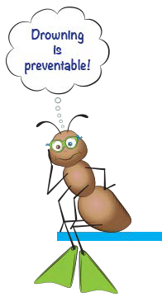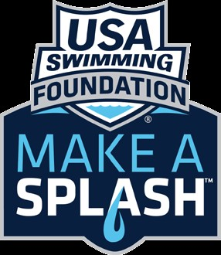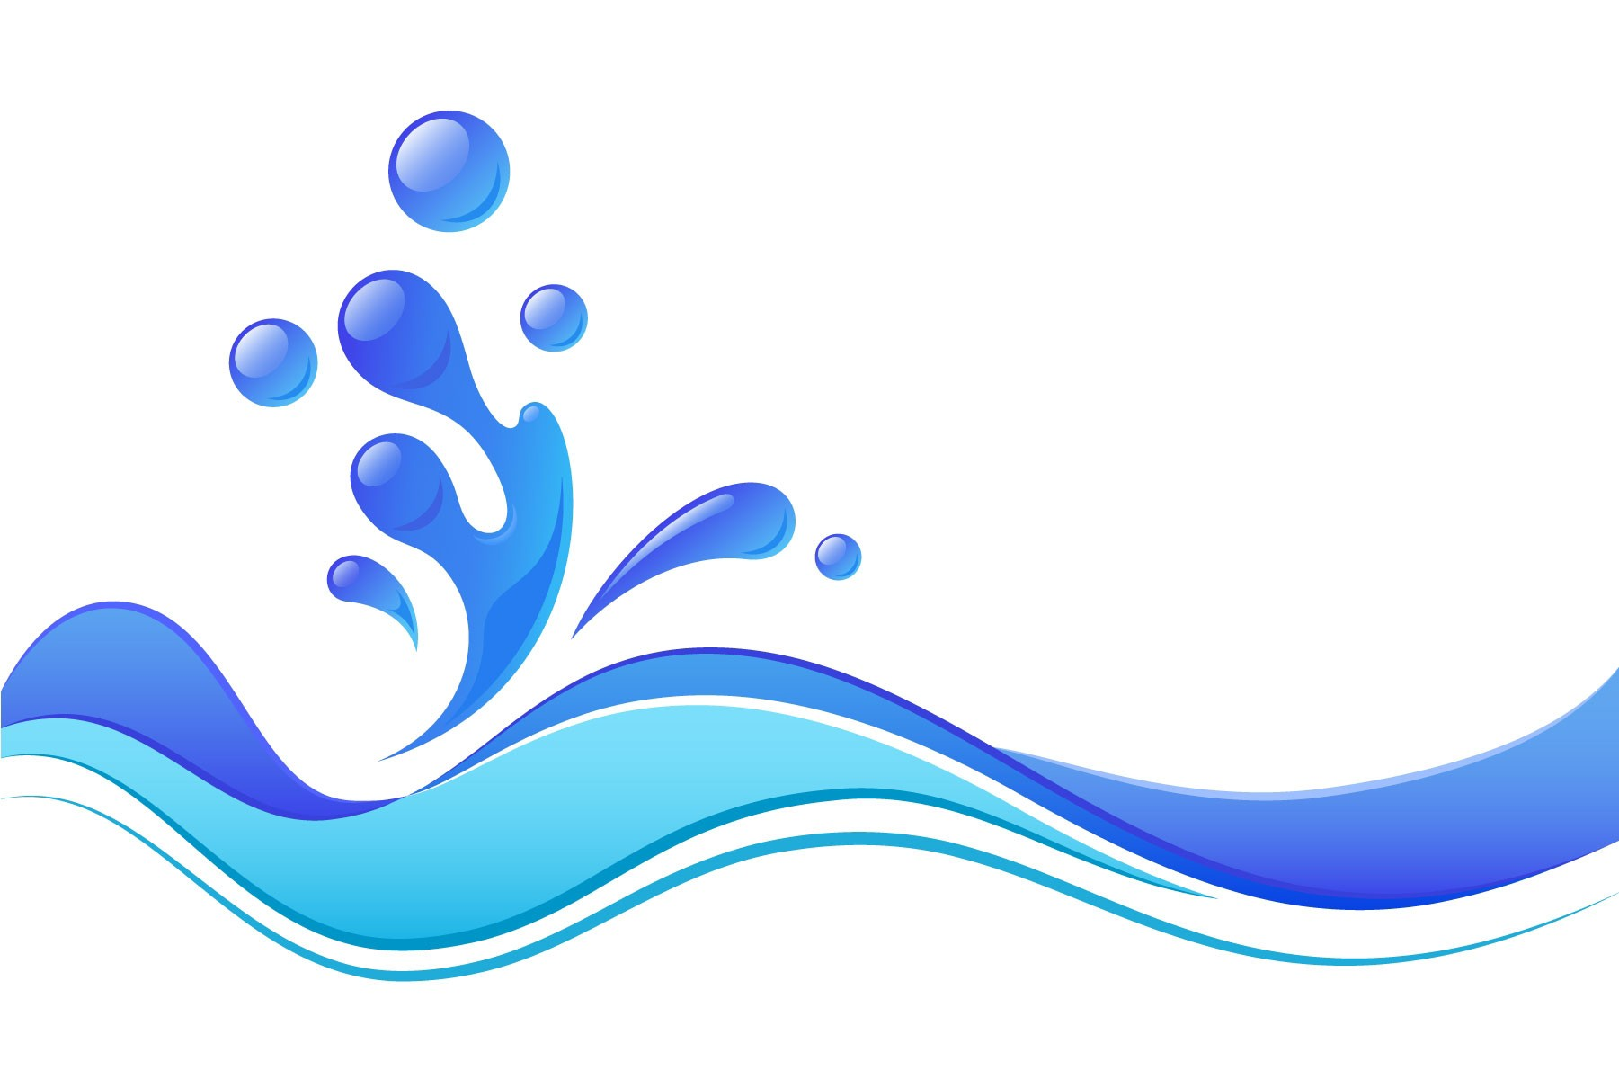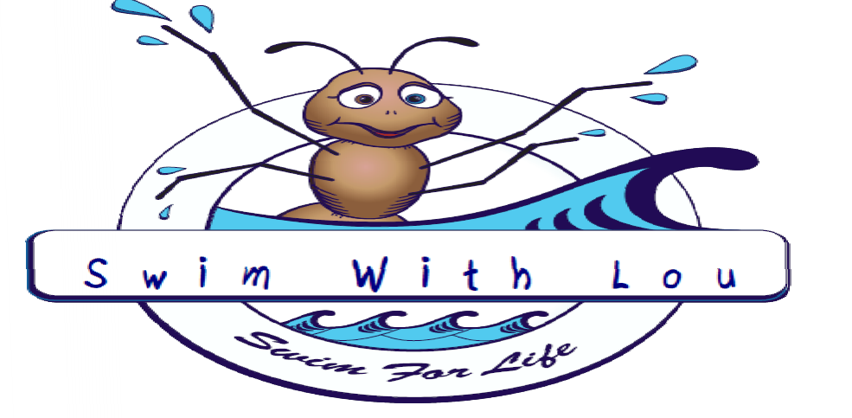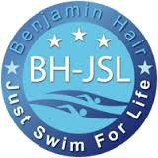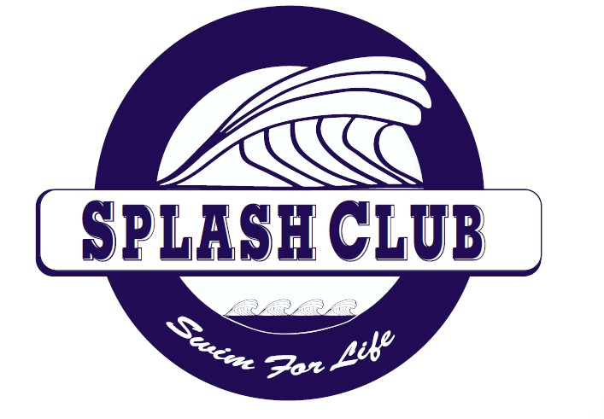
The Need
Drowning is the leading cause of accidental death in the U.S. among children under 14 and the leading cause of accidental death for children ﬁve and under.
- In 2007, there were 3,443 fatal unintentional drownings in the United States, averaging ten deaths per day.
- More than one in five fatal drowning victims are children 14 and younger. For every child who dies from drowning, another four received emergency care for
nonfatal submersion injuries
- 70% of African American children, 58% of Hispanic children, and 40% of Caucasian children have low or no swimming ability, and are at
a high risk of drowning.
- The key indicator in swimming ability was not race, but family--
children from nonswimming households are 8 times as likely to be at risk for drowning.
Make a Splash Program is a national child-focused water safety initiative that has the goal of teaching every child in America how to swim. BH-JSL works with Make a Splash Local Partners to hold swim lessons and promote water safety throughout central Virginia and beyond.

The mission of the Ben Hair Just Swim For Life Foundation (BH- JSL) is to raise the awareness of the need, and to provide motivation, systems, and tools to waterproof our community so that all children have basic swimming skills and are safe around the water.

The Ben Hair Just Swim for Life Foundation is a 501(c)(3) non-proﬁt organization based in Charlottesville, Virginia. We would greatly appreciate any donations to support free swim lessons in our community and ensure that everyone is safe around the water.
For Donation information, visit:
www.bhjsl.org and click on the “Make a Donation” link.
www.BHJSL.org
BEN HAIR JUST SWIM FOR LIFE

Ben Hair Just Swim for Life is Starting a New
USA Swim Team. "Ben Hair Splash Club"
Beginners : Swim with Lou

Stroke Development: Splash Club

General Info:
How Do I Enroll?

Swim With Lou will be offered by BH-JSL at:
- Crow Pool
1700 Rose Hill Drive Charlottesville ,VA 22903
- Fairview Swim and Tennis Club
707 Belvedere Boulevard
Charlottesville, Va 22901
- more locations coming soon.
To Enroll, please call the Ben Hair Just Swim for Life Foundation at:
(434) 973-3838
and ask about the Ben Hair Just Swim for Life Swimming program
at Crow Pool and Fairview Swim and Tennis Club Programs

A registration fee will be required to enroll in these classes. Fees vary depending on class type and time of year. BH-JSL will always strive to keep lesson fees the most competitive in the area. Your lesson fee helps us provide swim lessons to those who can not afford to pay for this life saving skill.
Swim With Lou Includes 16 sessions.
Sessions are offered 2 days per
week for a 8 week period.
Lessons are held in the afternoon/ evening hours.
Call the BH-JSL offices now for complete scheduling information and to register.

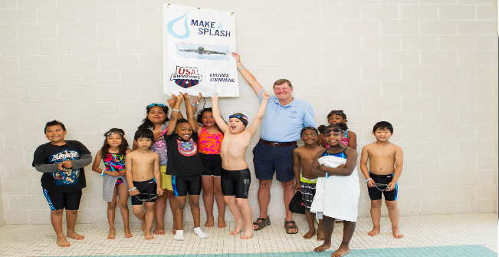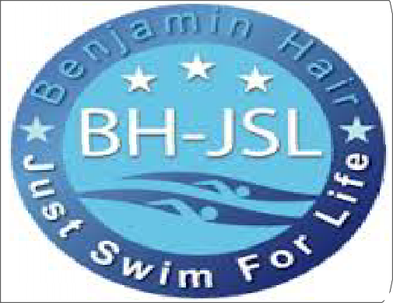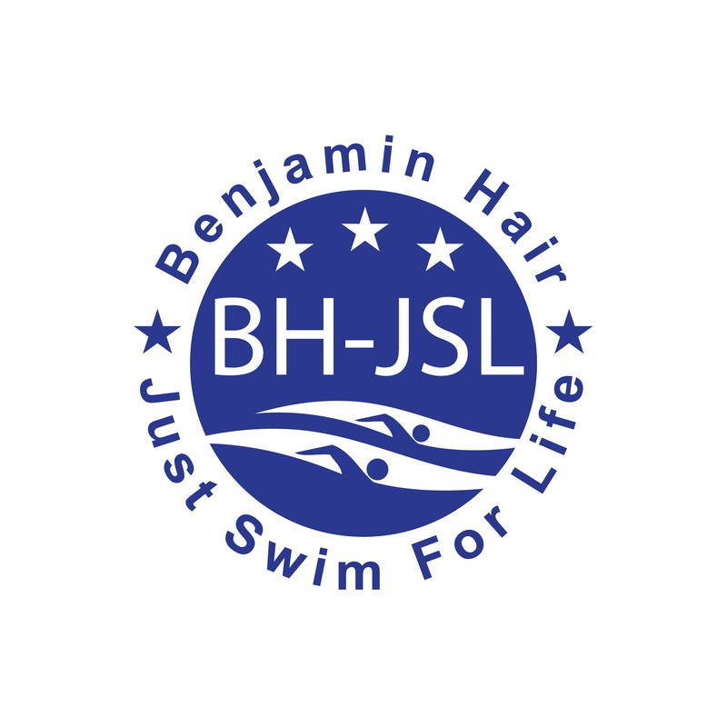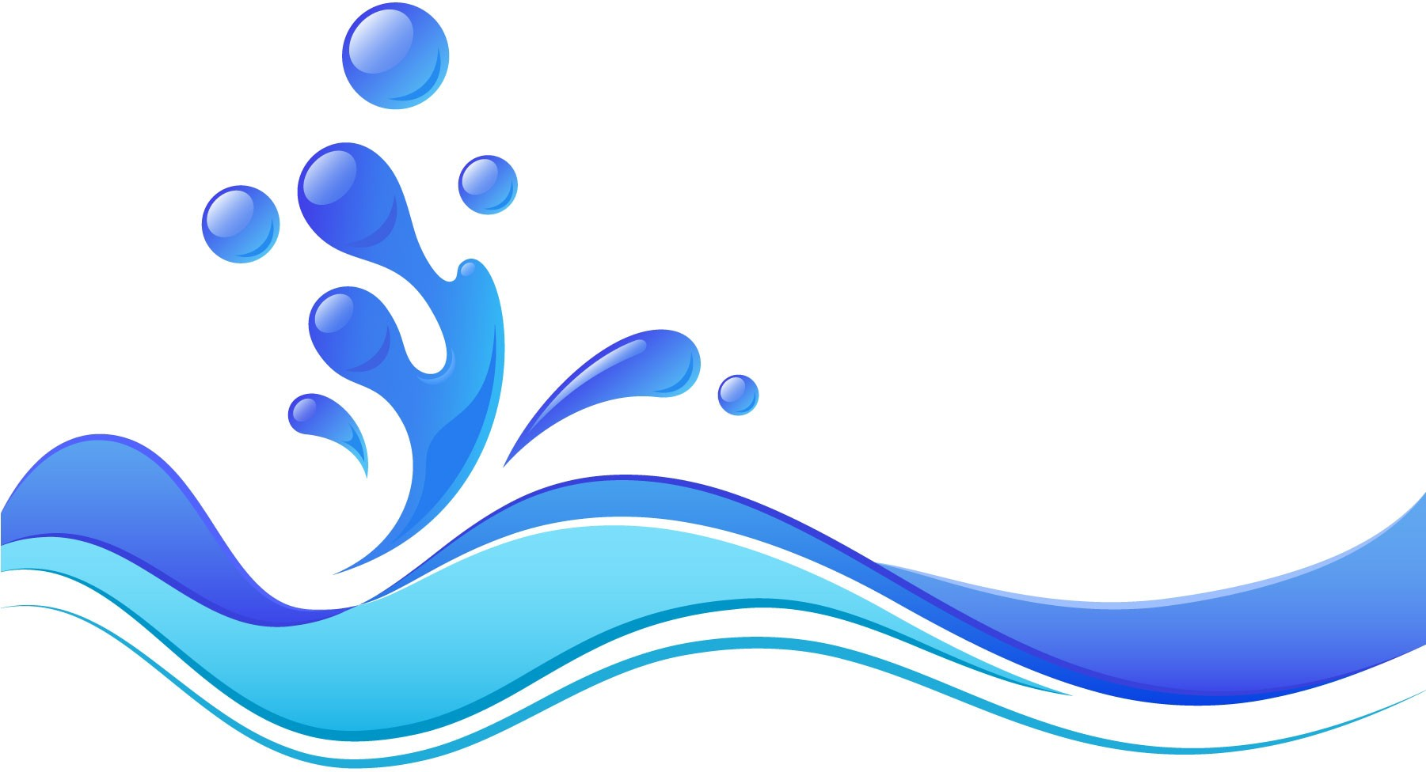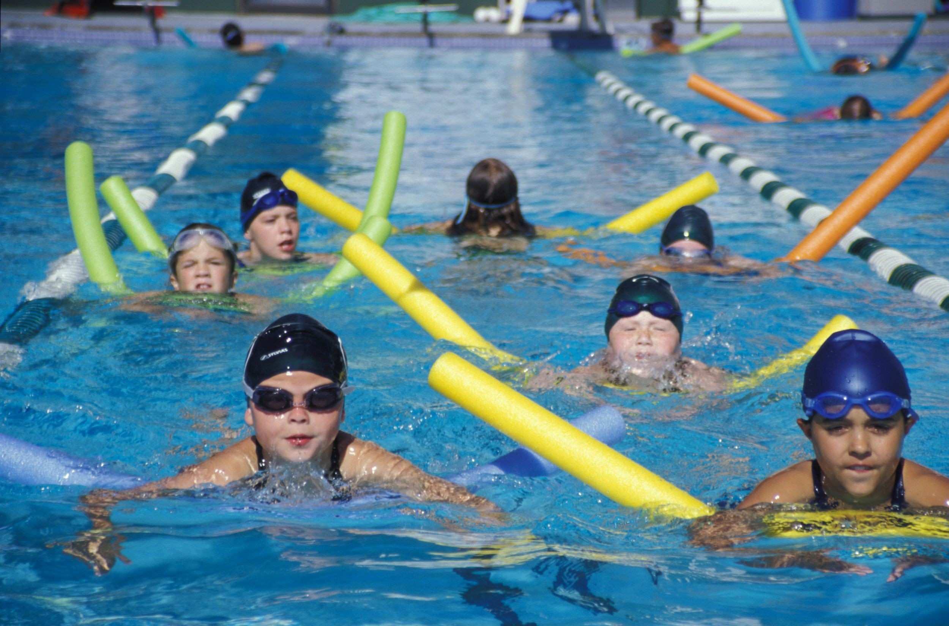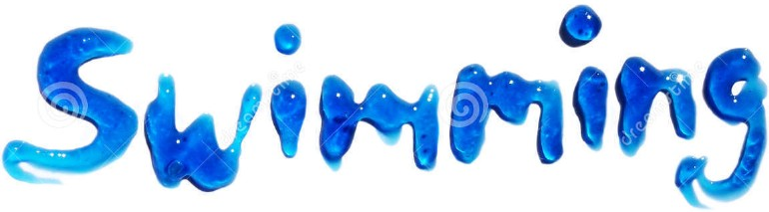
All lessons will be taught by a Certified USA Swim Coach using the Ten Swim with Lou Principles and volunteer swim instructors.
Swim with Lou: Basic
Introduction to Water Skills.

Splash Club: Some level of comfort in the water. Fundamental Aquatic Skills and Stroke Development.
These Lessons are intended for
Beginning Swimmers for ages 5 and up. Swim with Lou and Splash Club are members of USA Swimming

