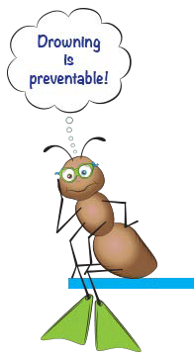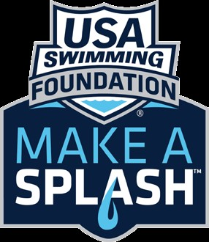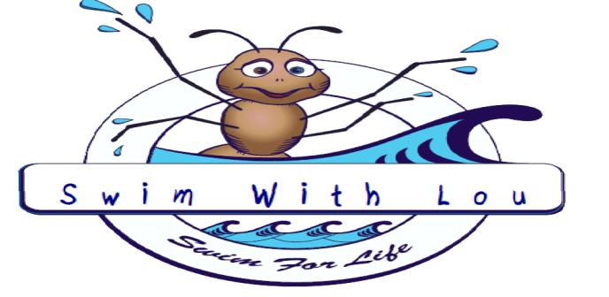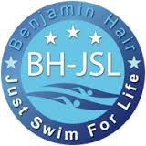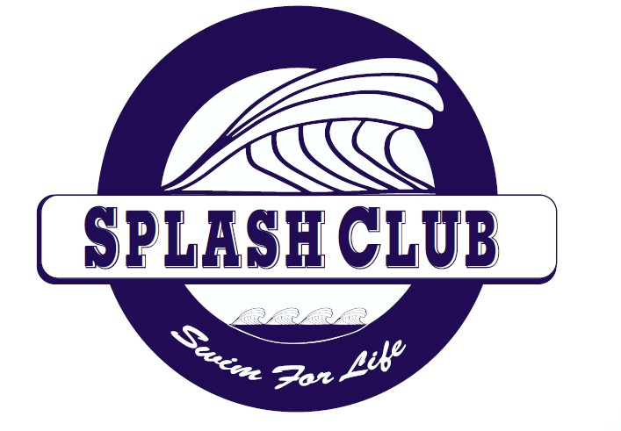
The Need
Drowning is the leading cause of accidental death in the U.S. among children under 14 and the leading cause of accidental death for children ﬁve and under.
- In 2007, there were 3,443 fatal unintentional drownings in the United States, averaging ten deaths per day.
- More than one in five fatal drowning victims are children 14 and younger. For every child who dies from drowning, another four received emergency care for
nonfatal submersion injuries
- 70% of African American children, 58% of Hispanic children, and 40% of Caucasian children have low or no swimming ability, and are at
a high risk of drowning.
- The key indicator in swimming ability was not race, but family--
children from nonswimming households are 8 times as likely to be at risk for drowning.
Make a Splash Program is a national child-focused water safety initiative that has the goal of teaching every child in America how to swim. BH-JSL works with Make a Splash Local Partners to hold swim lessons and promote water safety throughout central Virginia and beyond.

The mission of the Ben Hair Just Swim For Life Foundation (BH- JSL) is to raise the awareness of the need, and to provide motivation, systems, and tools to waterproof our community so that all children have basic swimming skills and are safe around the water.

The Ben Hair Just Swim for Life Foundation is a 501(c)(3) non-proﬁt organization based in Charlottesville, Virginia. We would greatly appreciate any donations to support free swim lessons in our community and ensure that everyone is safe around the water.
For Donation information, visit:
www.bhjsl.org and click on the “Make a Donation” link.
www.BHJSL.org
BEN HAIR JUST SWIM FOR LIFE

Ben Hair Just Swim for Life is Starting a New
USA Swim Team. "Ben Hair Splash Club"
Beginners : Swim with Lou

Stroke Development: Splash Club

Save A Life
CPR Party

Who Should take a CPR Class?

- If you have ever been certified in CPR and need a refresher
- If you have ever wanted to learn CPR
- You want you become familiar with CPR
- If you are an adult
- If you are a teenager
- If you are ever in public situations
- If you have any interest at all

The reason most people do not act in the case of an emergency is because they have not been trained or practiced.
We can train you and give you a place to practice!!

Call 434-973-3838 to register
Classes are offered multiple times a month
Check Facebook.com/justswimforlife
for the current teaching schedule

