Does your Child need to learn how to Swim?
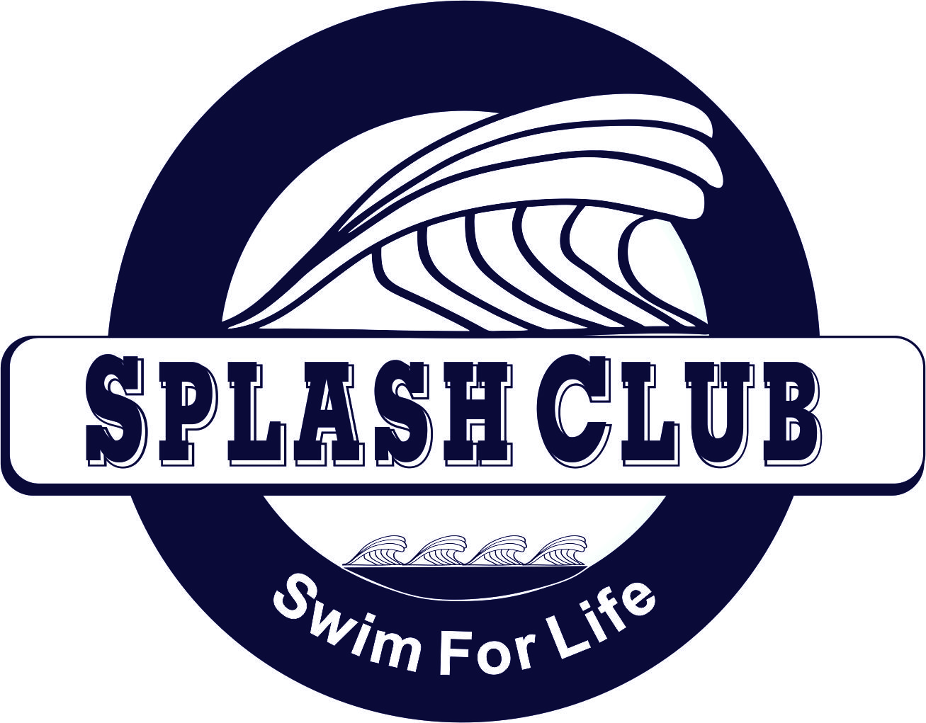
Splash Club is a program for beginners through experienced swimmers.
Monday and Wednesday 3:15- 4:00 pm
@ Fairview Swim and Tennis Club
(Scholarship assistance available for qualifying students)
Contact the Ben Hair Just Swim for Life Foundation for more information.
434-973-3838 or Exec.bhjsl@outlook.com
Ben Hair Just Swim for Life Foundation is a 501(c)3 organization dedicated to waterproofing the Central Virginia area through drowning prevention education and swim lessons.

